14. Endocrine Control of Mammalian Reproduction *(RHM: Chapters 49, 50)*

______________________________________________________________________________

I. Development of Sexual Characters

A. Early Development

B. Hormonal Initiation of Puberty

II. The Human Menstrual Cycle  *(1152-1160)*

A. Sites of Important Changes

B. Flow Phase

C. Follicular Phase

1. Post‑menses condition

2. Follicle stimulating hormone (FSH) / luteinizing hormone (LH)

3. Estrogen

D. Ovulation

1. Effects of estrogen

2. Luteinizing hormone (LH) and ovulation

3. Production of corpus luteum

E. Luteal Phase

1. Estrogen concentration reduction

2. Progesterone production

3. Effects of progesterone

F. Reinitiation of Menses

1. Shedding of endometrium

2. Deinhibition of hypothalamus

3. Feedback system

III. Action of Birth Control Pills *(1160-1161)*

IV. Reproductive Cycles in Other Mammals

A. Periodicities of Cycles

B. Changes Induced in Advance of Ovulation

C. Timing of Ovulation

D. Uniqueness of the Human Cycle

V. Hormonal Control of Pregnancy *(1176-1181)*

A. Fertilization

1. Timing

2. Location

3. Movement of zygote

B. Implantation and Maintenance of Fetus

1. Placenta

2. Fetal membranes

C. Hormone Production

14-1

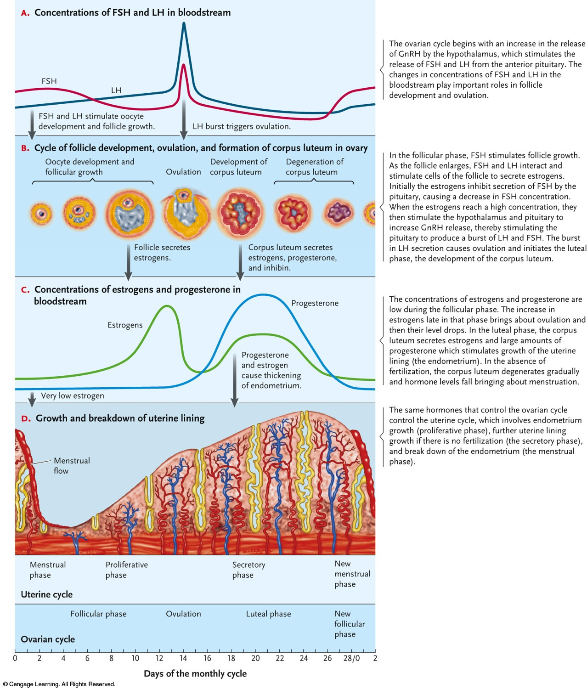

14-2

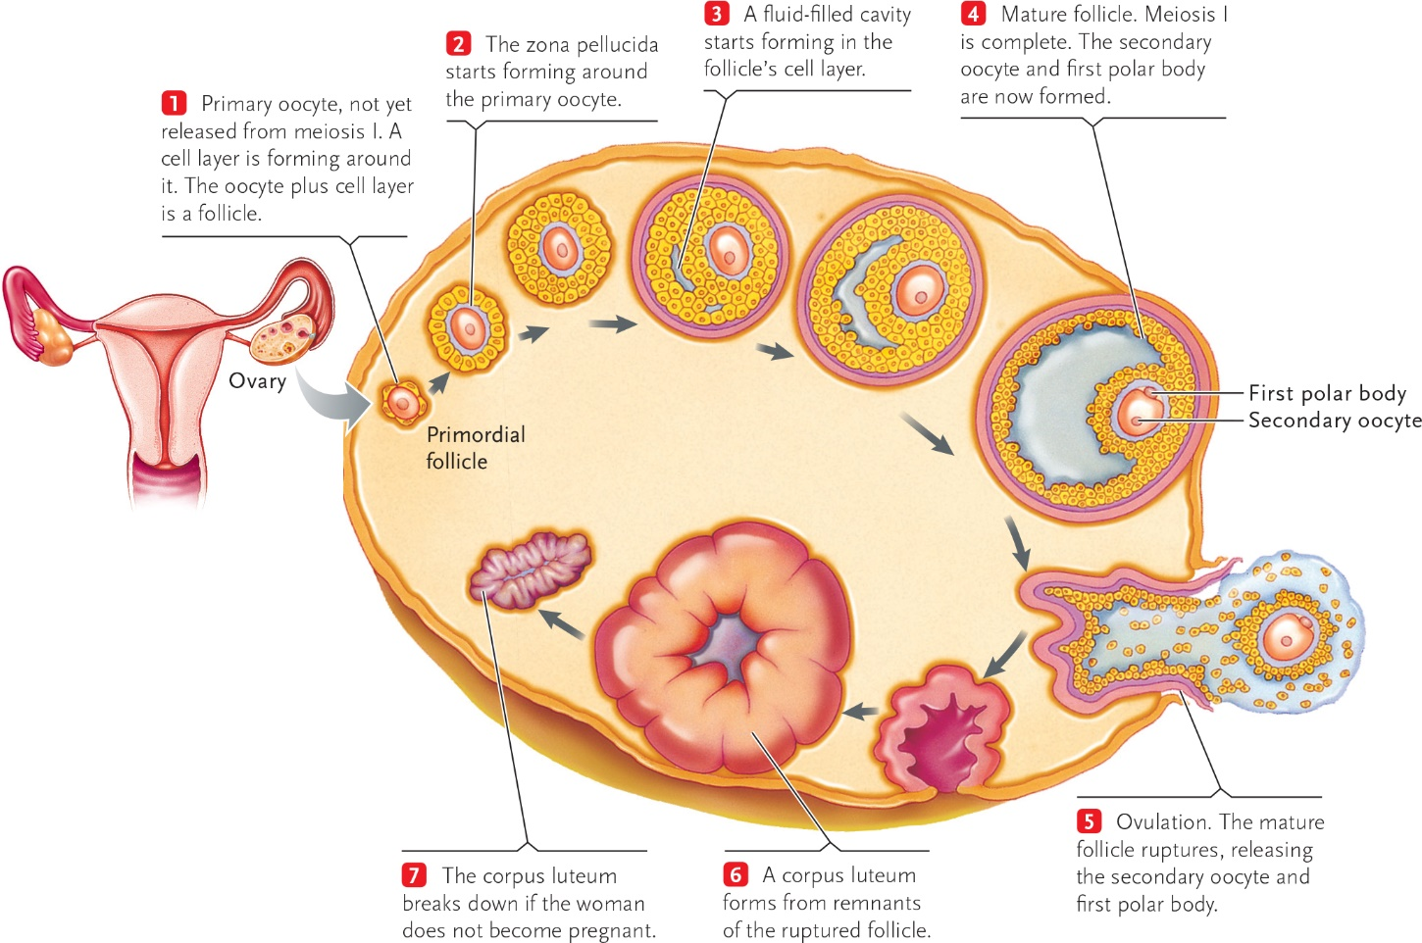

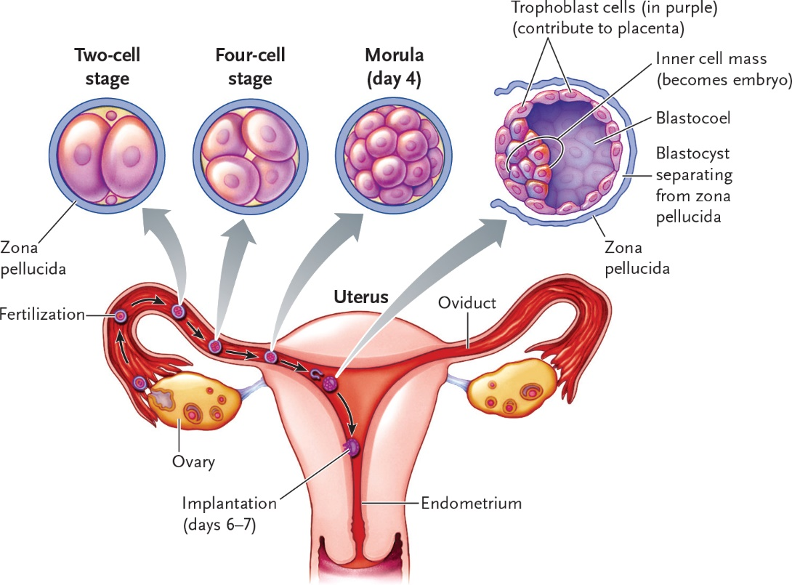

14-3

